**========Project 7=======**

**Name-** **DevOps-Jenkins-Installation and Configuration on Linux**

**Install latest version of java-**

yum install java-1.8*

**To download the jenkins.repo and jenkins.io key –**

<https://pkg.jenkins.io/redhat-stable/>

sudo wget -O /etc/yum.repos.d/jenkins.repo https://pkg.jenkins.io/redhat-stable/jenkins.repo

sudo rpm --import <https://pkg.jenkins.io/redhat-stable/jenkins.io.key>

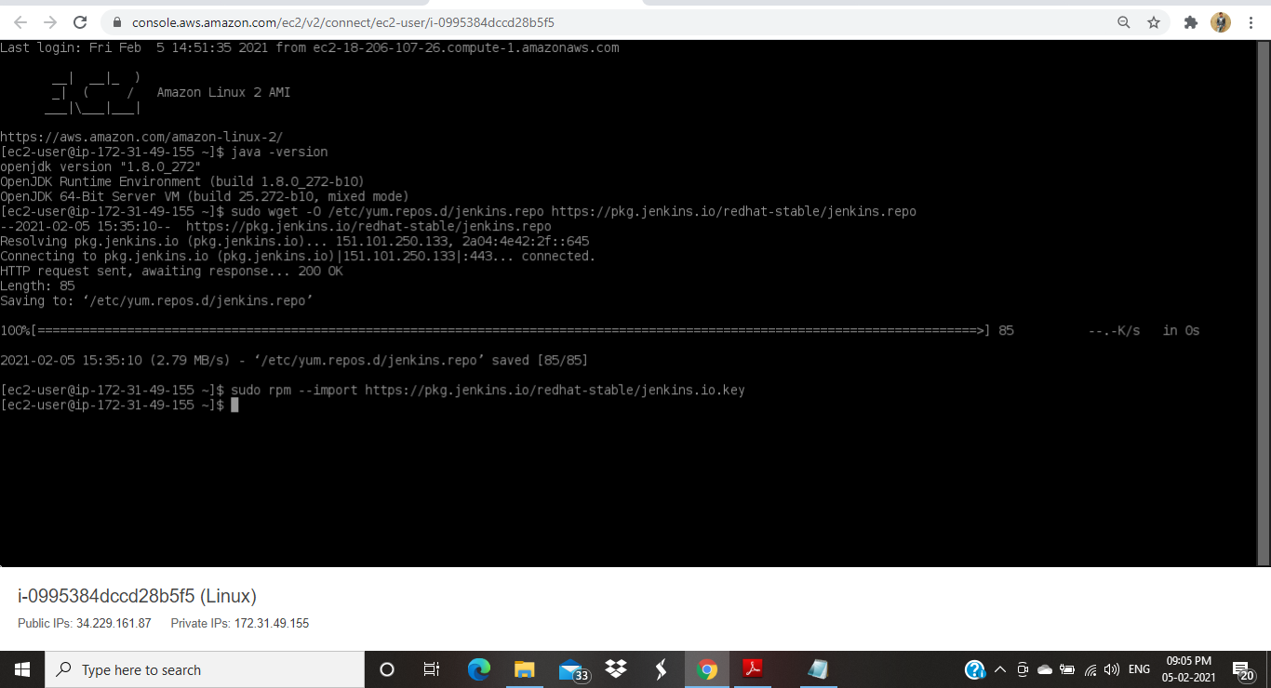

**To install jenkinks – yum install Jenkins**

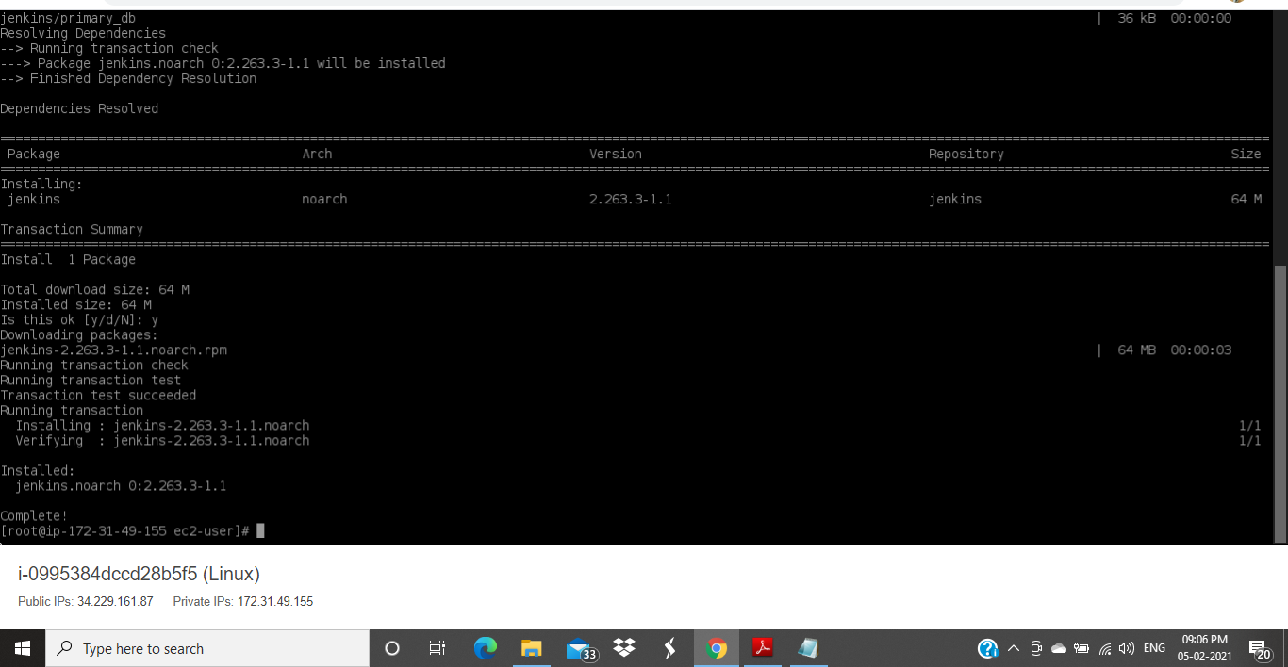

**Start the Jenkins – service jenkins start**

**Copy paste the location present in the Jenkins page to extract the password –**

**cat /var/lib/jenkins/Secrets/intialAdminPassword**

**Copy the password and login to Jenkins.**

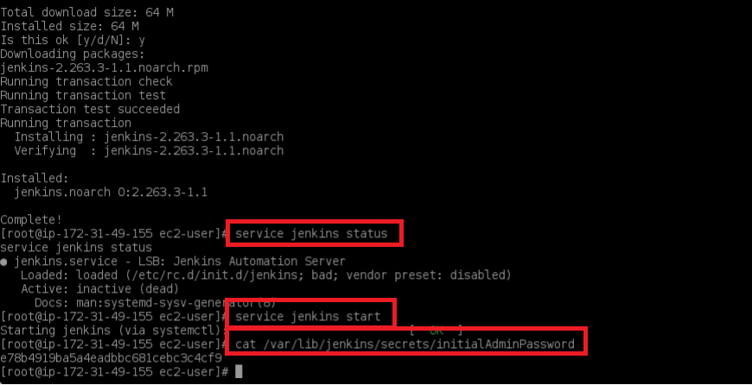

**Using public IP and default port-8080 login to jenkins-** [**http://34.229.161.87:8080**](http://34.229.161.87:8080) **skip the plugin installation and continue. Next change the admin password from admin band.**

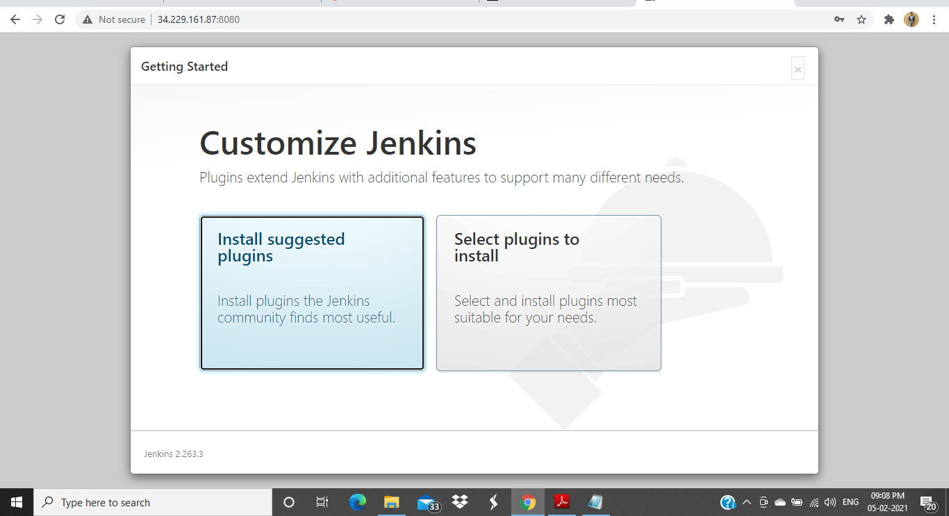

**Create job using shell and build the job –**

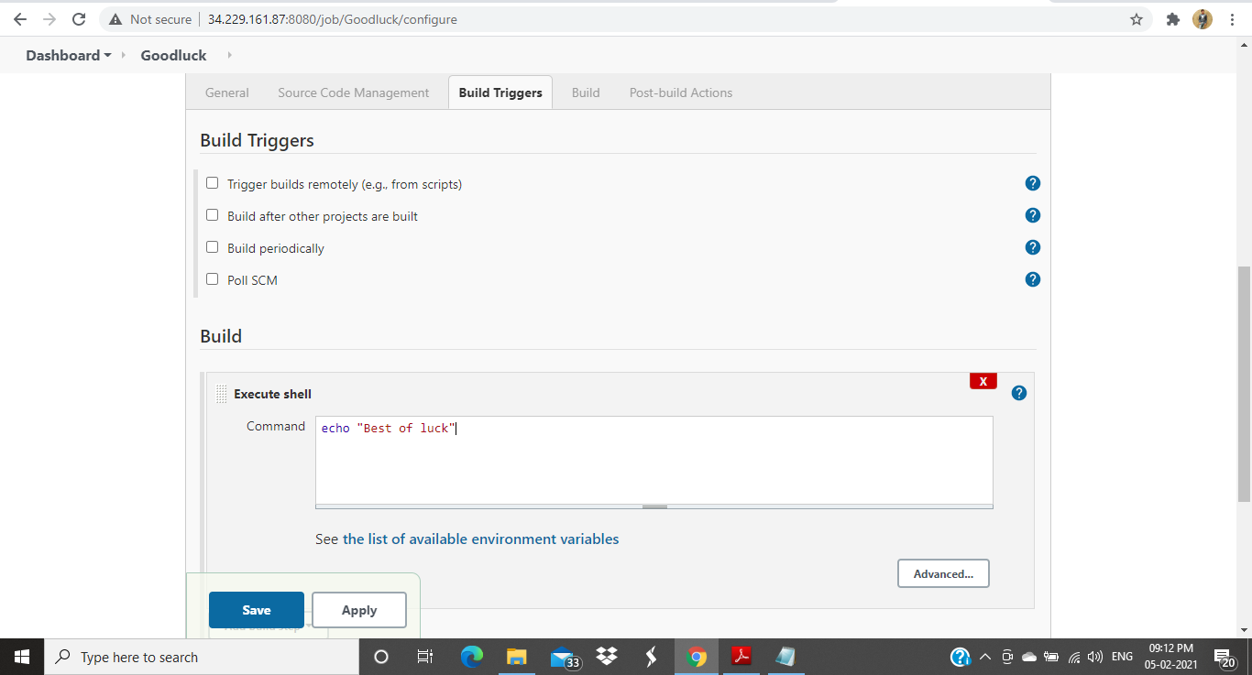

**Console output of job -**

